|  |
| --- |
| 新东方在线英语学习 |
| 新概念 2 册 |
| Lesson17 |



扫一扫。更多有趣的英语资讯。

1. appear v. 登场，扮演

disappear v.

appearance n. 出现，外貌

1. stage n. 舞台on the stage
2. stage fright

怯场

1. bright adj. 鲜艳的bright colour (color)

光明的

bright future / prospect

聪明的

bright ideas

The little boy is really bright.

Key points:

情态动词 must

1. 表示推测
2. 表示不可避免的义务

# Lesson 17 单词讲解

**Lesson 17 课文&语法讲解**

* 1. She must be … thirty-five years old.

情态动词

shall should …

* must 情态动词

Can clould

May might

Will would

Shall should

1 表示推测

* She must be 35 years old.

对比：She is 35 years old.

* You must be the new teacher.
* He looks pale.
* He must be ill. must 情态动词

1. 表示推测
   * She must be 35 years old. 推测现在
   * It must have rained last night. 推测过去
   * She must have cried just now.
2. 表示不可避免的义务
   * I must do it now.
   * She must do it now.
   * You must do it tomorrow.
   1. In spite of this, she often appears … as a young girl.
   2. Jennifer will have to take part in a … play soon.
   3. In the play, he must appear in a bright red dress …
   4. Last year in another play, she had to wear short socks …

At least 至少

情态动词 依然是动词 只不过不表示动作了

Cloud might 不仅仅表示过去式 还表示客气的说法  
must想表示推测过去，但是must还必须加原型 所以要想推测过去

得用如下这个

Must have done

Must=have to

Have to 也表示必须，have to在时态上能更精确一点，要想表示过去时候推测，可以使用had to

# Lesson 17 知识拓展

**情态动词 must**

1 “必须” ／ “非要，偏要” 2 “禁止” mustn’t

3 “肯定，一定”

推测现在 must do

推测过去 must have done

* Shall I inform him of the change of the schedule right now?
* I am afraid you , in case he comes late for the meeting.

1. will
2. must
3. may
4. can (2011 福建 25)

* you interrupt now? Can’t you see I’m on the phone?
* Sorry Sir, but it’s urgent.

1. Can
2. Should

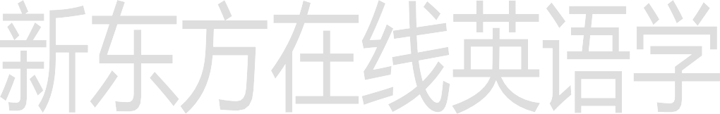

1. Must
2. Would (2012 重庆 25)

If you smoke, please go outside.

A. can

1. should
2. must
3. may (2011 全国 8)

The new law states that people drive after drinking alcohol.

1. wouldn’t
2. needn’t
3. won’t
4. mustn’t (2012 上海 28)

* Good morning. I’ve got an appointment with Miss Smith in the Personnel Department.
* Ah, good morning. You be Mrs. Peters.

1. might
2. must
3. would
4. can (2010 北京 23)

“You have a wrong number,” she said. “There’s no one of that name here.”

1. need
2. can
3. must
4. would (2010 浙江 17)

It have been Tom that parked the car here, as he is the only one with a car.

1. may
2. can
3. must
4. should (2009 上海 27)

Jack described his father, who a brave boy many years ago, as a strong-willed man.

1. would be
2. would have been
3. must be
4. must have been (2010 安徽 32)

* There must have been a long trip.
* Yeah, it us a whole week to get there.

1. takes
2. has taken
3. took
4. was taking (2011 北京 27)

* There must have been a long trip.
* Yeah, it us a whole week to get there.

1. takes
2. has taken
3. took
4. was taking (2011 北京 27)